Entering new contacts into vision

1. Go to the Navigation bar on the left side of the screen. Go to the drop down for Info Center, and select Clients.

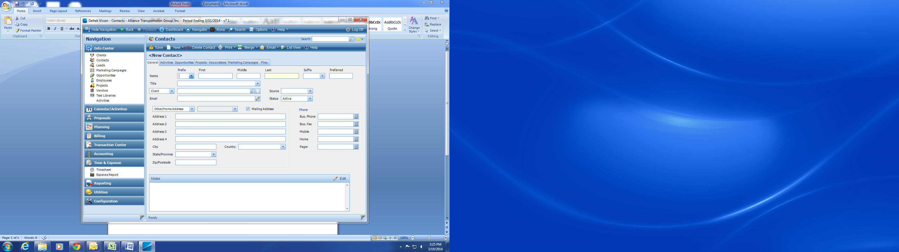

1. 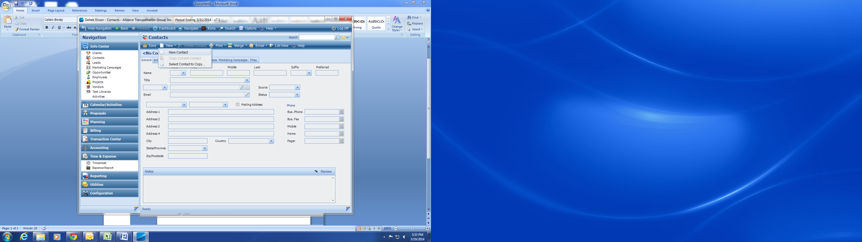Next, you are going to go to New on the contacts menu and select new contact.
2. The next step is to enter in the information in the given fields. However, when you get to the client field you need to look up and select the correct client (Company they work for). This will also help generate the other fields such as address, phone, and fax many times.

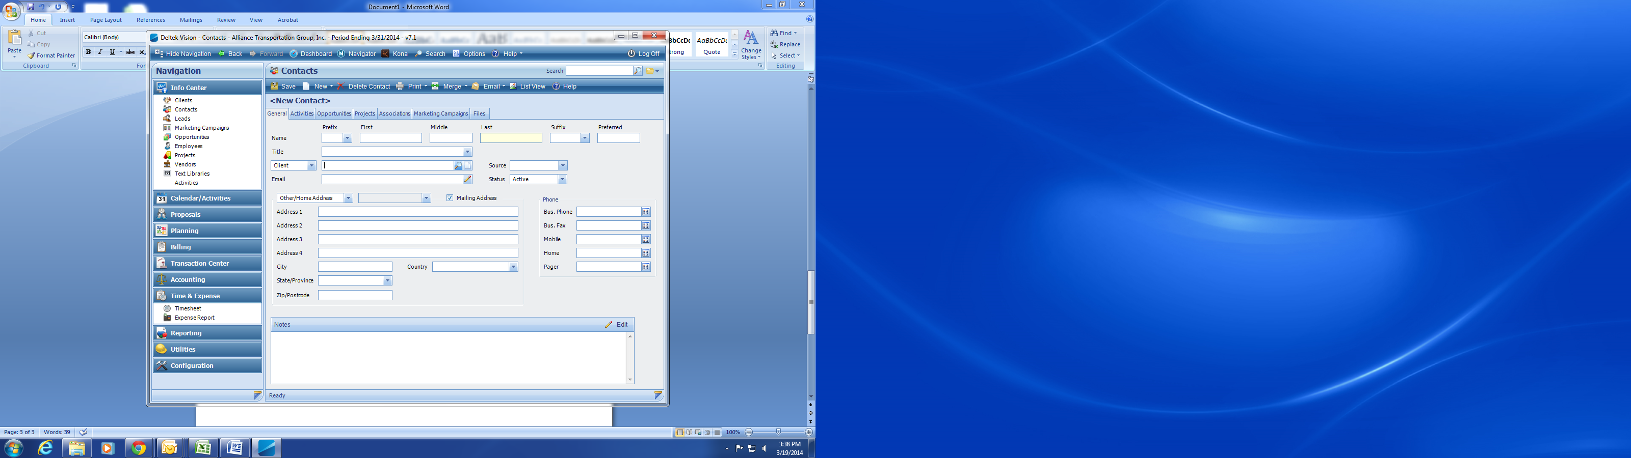

1. After you click on the magnifying glass this client lookup will be generated. Go to Search Text (Do not change any other fields) and then press enter.

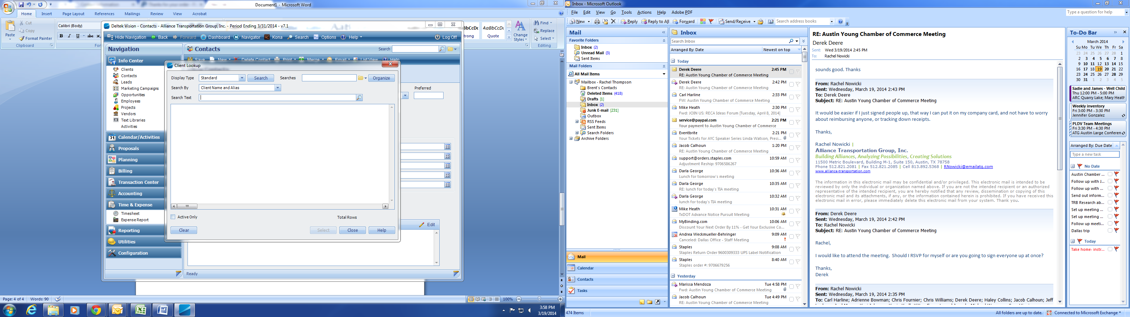

1. For Example, I type HNTB for the company, I hit enter and it is generated in the list box below, select HNTB (either by highlighting and clicking select or simply double click) and it will generate the rest of the fields from the default company information.

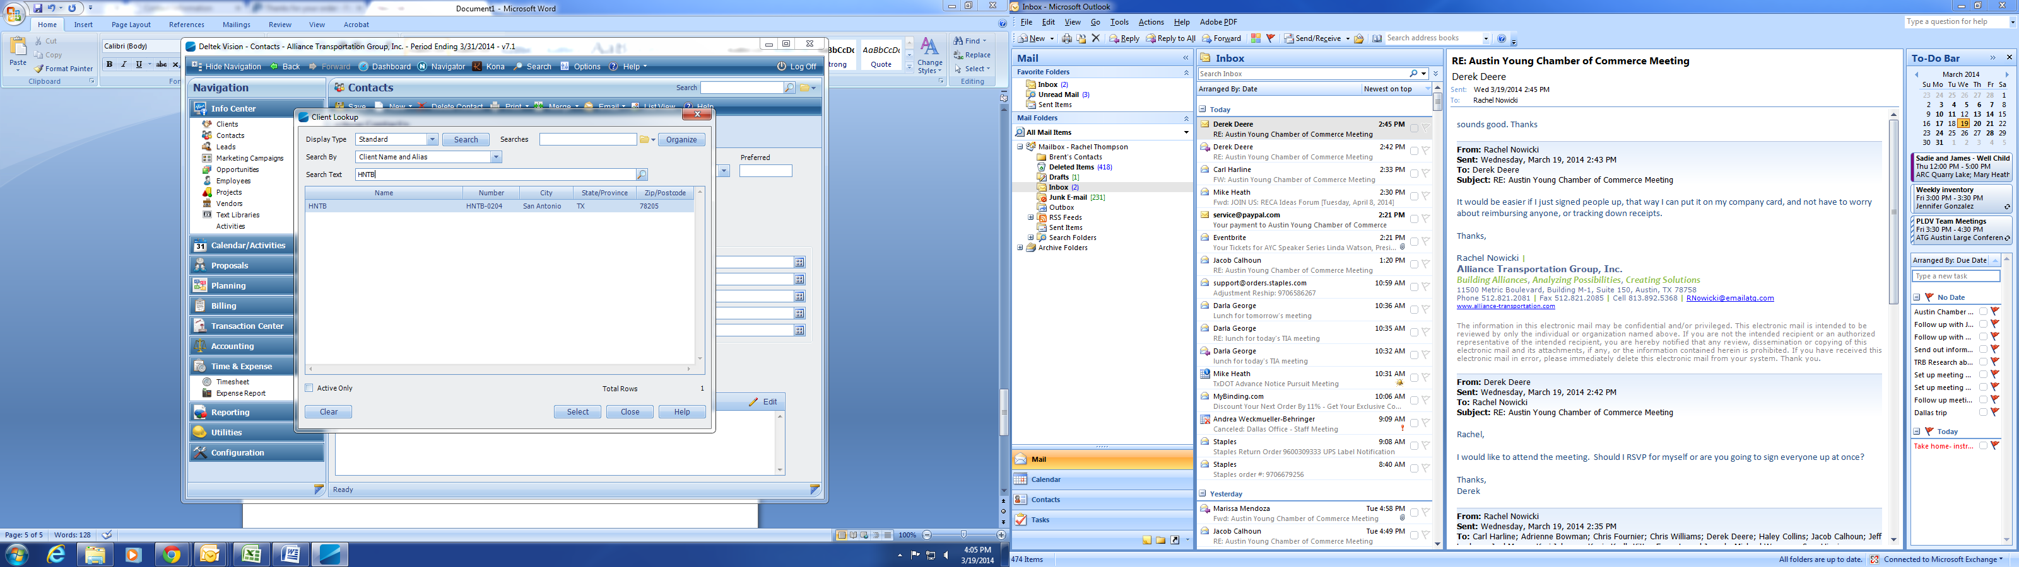

1. Your form will then be auto-generated. All that should need to be entered beside name and title is email. If it is a company with more than one office location, you can select the correct corresponding address from the client address sub drop down screen. Verify that you have selected the correct city and address as some companies have more than one office in the same city.

